SHAMLEY GREEN VILLAGE HALL ANNUAL GENERAL MEETING
WEDNESDAY, 15 MAY 2024 AT 7.45 PM
ARBUTHNOT HALL

 | Management Committee Attendees:
 | Elected Members: Jon Watson (Chairman), Paulina Bayliss (Secretary), Fiona Cameron, Jim Drummond, Chris Howard
 | Representative Members: Tim Harlow, Lindsey Slater
 | Co-opted Members: None
 | Associate Members: Lyn Barber.
 | Members of the Public: 35 people attended
1. | Welcome
 | Jon Watson thanked all for coming and introduced himself as Chairman.
2. | Apologies for Absence:
 | Mike Band, Ali Bull (Hall Manager), Lucy Camsey (Elected Member), Sally Davies, Neil and Alison Harding, Alastair Hilton (Co-opted Member), Gill Morris (Treasurer), Anthony Shutes, Simon and Aurelle Tomkins (Associate Member), Gary and Ginny Wicks.
3. | Approval of Minutes of the Annual General Meeting held on 23 April 2023:
 | It was noted that Gill Morris was a Co-opted Member rather than an Elected Member of the Committee. The minutes will be amended accordingly.
 | Otherwise they were approved by the meeting.
4. | Chairman’s Report - Jon Watson
 | The report is attached to these minutes and is included on the Hall website - https://www.arbuthnothall.org
Topics covered included:
- Progress
- Finances
- Expansion of Use of the Hall
- Hall Managed Events and Marketing
- Property Development
- Fundraising
- Governance
- Bank Account
- Change in Governance
- Current Management Committee
- Growth, Time and Resources
5. | Treasurer’s Report - Jon Watson
 | Jon Watson presented the report on behalf of Gill Morris. The detailed report is attached to these minutes and is included on the Hall website.
 | The Financial Accounts for the Shamley Green Village Hall known as Arbuthnot Hall for the 12-month period 1 March 2023 to 29 February 2024 were circulated around the room. They are attached to these minutes and will be included on the Hall website.
Operating Income and Expenses
Total operating income increased to £23,852 from £23,343, within which hire charges increased to £9,305 and Hall own events income increased to £13,778.
Total operating expenses reduced to £17,924 from £26,532.
Net operating surplus £5,924.
Consolidated Report
Total Income reached £78K, less expenses expenditure of £32K resulting in a total surplus for the period of £46K.
 | Balance sheet is dominated by £85K cash held of which £34K held for property development
Donations and Property Development
In the accounting year to 29 February 2024, £48K was raised in donations plus, for the first time, £4,957 in respect of Gift Aid. Interest and net investment income reached £974. This follows the liquidation to cash of the hall Investment Portfolio due to the termination of the management agreement by CAF with their investment managers.
 | Expenditure on property development in the period totalled £14,275. As a policy, all budgeted expenditure on the Hall development at the point of contract must be covered by cash held.
Independent Examiner
Richard Holmes FCA has conducted an Independent Review of these accounts in accordance with the Charities Act 2011 and given a clean bill of health.
 | Approval of the report was proposed by Chris Howard and seconded by Penny Hodgson.
 | Kevin Garvey commended Gill for the work done with the new accounting software package. He suggested that prior year headings should be shown. He also asked if the division between the Gold and the Development accounts was the decision of the Committee. Jon Watson confirmed that separate bank accounts had been established for the donations and Hall development fund
6. | Appointment of the Elected Members (Trustees) to the Management Committee - Paulina Bayliss
 | Mike Band was nominated by John Page and Artar Shareef.
 | Paulina Bayliss was nominated by Penny Hodgson and seconded by Lynda Rice.
 | Fiona Cameron was nominated by Lucy Camsey and seconded by Jon Watson.
 | Lucy Camsey was nominated by Raymonde Jay and seconded by Annabelle Ball.
 | Jon Watson was nominated by Gary Wicks and seconded by Helena Watson.
 | Unanimous approval was given for the above appointments.
7. | Appointment of the Representative Members (Trustees) to the Management Committee - Paulina Bayliss
 | Shamley Green Fête Committee has appointed Tim Harlow.
 | Shamley Green Cricket Club has appointed Jim Drummond.
 | The Shamley Green Village Association has appointed Lindsey Slater.
 | Wonersh Parish Council has appointed Christine Howard.
 | It was noted that these individuals were duly appointed to serve for the following year.
8. | Appointment of Co-opted Members (Trustees) to the Management Committee - Paulina Bayliss
 | Alastair Hilton and Gill Morris have confirmed that they are willing to continue to serve and these appointments will be approved at the next Management Committee meeting.
9. | Appointment of Associate Members (Non-Trustees) to the Management Committee - Paulina Bayliss
 | Aurelle Tomkins (on behalf of the Shamley Green Gardening Club) and Lyn Barber have both confirmed their willingness to continue to serve and these appointments will be approved at the next Management Committee meeting.
10. | Motion to Change the Constitution - Jon Watson
 | It is proposed that the Constitution of Shamley Green Village Hall, known as the Arbuthnot Hall, Charity No 305149 dated 5 May 1966 as amended 19 October 1989, be changed as follows:
Clause 3 - delete existing clause of the Deed Dated 5 May 1966 below:
Cash - sums of Cash at any time belonging to the charity and not needed for immediate working purposes shall be invested in the name of the said Official Custodian unless the Charity Commissioners otherwise direct.
Insert new clause
Cash - sums of Cash at any time belonging to the Charity shall be deposited in the name of the Charity with CAF Bank Limited and or any other UK Authorised Bank and or in the name of the said Official Custodian unless Charity Commissioners otherwise direct.
 | Kevin Garvey asked what the next steps would be in giving approval. Jon Watson said that a policy document would be developed and permission to change the constitution would be obtained from the Charity Commission.
 | Unanimous approval for the motion was given.
11. | The Hall Development Report - Jon Watson
 | At the AGM, 23 April 2023, a procurement timeline was put forward, in the knowledge that there would need to be some flexibility in this.
 | Procurement Timeline - A Year On
 | Phase 1 - Initial Concept Planning - completed.
 | Phase 2 - First Village Consultation 13 November 2022 - first design concepts introduced.
 | Phase 3 - Appointment of Architects, following issue of RFPs to three Practices and post submission interviews. Lytle Associates were appointed in July 2023, with a RIBA (the Royal Institute of British Architects) contract subsequently signed. Fees for RIBA phases 1-3 are set out below.
 | Phase 4 - Q4 2023. Commencement of detailed design work and appointment of the additional consultants required for the pre-planning work. Three quotes per consultant, were obtained. Those appointed with their fixed costs are set out below. Expenditure to date is £33,987.
 | 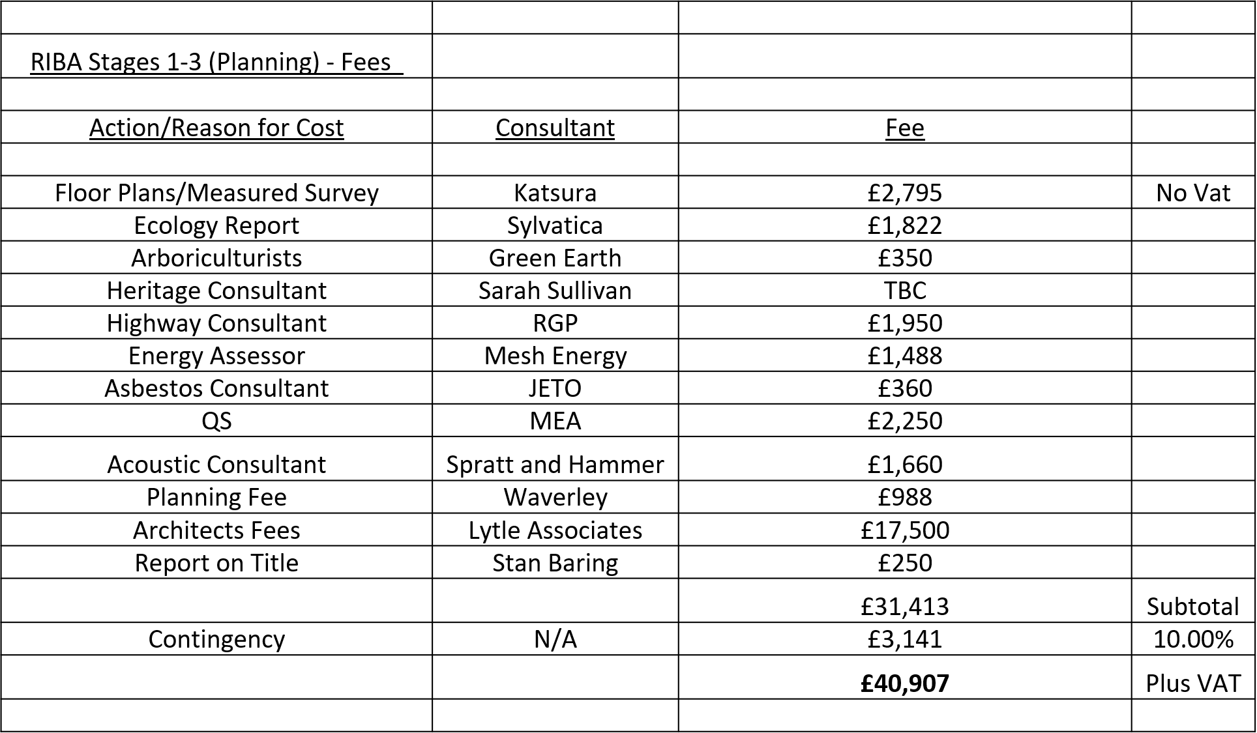
 | Phase 5 - Second Village Consultation 29 February 2024 - finalised drawings/plans that will go forward for Planning were presented to the Village. These are available to view on the Hall website.
 | Phase 6 - Planning application to be submitted Q2 2024
 | Phase 7 - Planning Consent targeted for Q4 2024.
Planning Application
In getting to this stage, both stakeholder and village involvement have been engaged, via the consultations, questionnaires, and meetings. This has been underpinned and supported by the procurement of the consultants as set out above, to put us in a position to submit the planning application.
 | All the necessary Consultant reports have been received which will support the Architectural Planning Application. The documents are in draft but will be finalised for submission in the next few weeks and authorised by Committee. The documents will be able to be viewed on Waverley’s Planning Portal once submitted. On the Arbuthnot Hall website, details and reference numbers will be provided for the Planning Application once submitted
Cost of Development
Having finalised the planning drawings, the scheme was costed by the appointed Quantity Surveyor (MEA). Work is underway with our Architects to bring the costs into line with our budget through a value engineering process.
The Ambition of the Management Committee
This remains unchanged - which is “to deliver a Community Facility which retains the Arts & Crafts heritage and secures the Hall as a sustainable community asset for future generations”.
12. | Events and Marketing Report - Lyn Barber
 | Lucy Camsey is also involved with running events and is particularly responsible for marketing.
Joint objective to:
Bring the village together to have fun
Raise funds to help with operating expenses
Regular events:
Spring and Autumn Brocante Fair
Arbuthnot Tennis Cup
Quiz Night
Christmas “Light up the Green” and Carol Singing
Wreath Making
Pickleball
Shamley Green Cinema
Looking Ahead:
Arbuthnot Tennis Cup
Pickleball continues plus Junior Sessions
Autumn Brocante
Quiz Night
Film Season starting in October
New - Bingo Night
New - Strictly Comes to Shamley Green
New - Basket Weaving Workshops
Christmas “Light up the Green” and Carol Singing
 | See the Hall website for details.
13. | Fundraising Report - Jim Drummond
 | Hall finances are looking better and covering operating costs. There is every confidence that this will continue. The continuing contributions of the 200 Club are gratefully received.
 | Funds For Redevelopment
 | Phase 1: About £40,000 were needed to pay architects and related costs to get to the planning application stage. Since the last AGM, this amount has been raised through the Friends of Arbuthnot Hall, Gift Aid linked to Friends contributions and funds from the Hall’s reserves.
 | The Hall now has about 50 Friends, who have paid either substantial one-off contributions or pledged regular donations or both. Thanks to members of the Management Committee who set a good example.
 | More Friends are needed. If you are not yet a Friend of the Hall or know someone who might become one - forms are available on the table.
Phase 2: At least £1million needs to be raised to cover the redevelopment plans.
There are four main sources:
 | - Larger institutional donors like the lottery fund and various government funds. The Parish Council has already offered a grant of £100,000. Most of these donors will need to see that planning permission has been granted before they will commit to provision of funds.
 | - Trusts, each with different criteria.
 | - Hall village fundraising events.
 | - Individual donations. Very generous offers have been made already but lots more will be needed. Gift Aid of 25% can be claimed from the HMRC from donations from income tax payers. The Hall has also benefitted from a very generous bequest from Jonathan Jenner, who departed far too soon. When the time is right, individual donors will be recognised publicly.
 | Advice and Business Case
 | The Committee is obtaining advice from various sources.
 | Small teams of volunteers from within the Committee and outside experts are being formed to lead on each of the above four areas.
 | Many funders will want to see a business case to support the development. Tim Harlow is tasked with preparing this. Cranleigh Village Hall received £300,000 from Waverley for “Levelling Up” and it has given us the business case it put forward.
 | If people would like to help with fundraising or know people who might, then please contact Jon Watson or Jim Drummond. The enterprise is a big job and more help is needed.
14. | Hall Operations - Jon Watson
 | Jon Watson presented the report on behalf of Ali Bull
The following items were particularly noted:
- repair of the cricket store roof and window
- replacement of gas piping
- repair of the header tank in the gent’s toilets
- a deep clean of the main hall and kitchen
15. | Governance Report - Fiona Cameron
 | Governance is all about the rules and regulations by which the Charity must abide, and which seem to be increasing all the time.
The Governance Subcommittee
This includes Jon Watson, Fiona Cameron, Chris Howard, Mike Band and Ali Bull, the Hall Manager. The group discuss more complex issues before they are brought to the full Committee with recommendations.
 | Governance issues addressed last year follow:
Safeguarding
This is all about the protection of children and vulnerable adults. After joining the committee last year, Fiona Cameron found herself the safeguarding lead and had a bit of a learning curve helped by some on-line training and local ladies with safeguarding experience including Penny Hodgson, and Diane Savage, the Church Safeguarding lead. Their help was very much appreciated. Lyn Barber was also involved with these discussions.
 | A safeguarding policy was produced which is now on the Hall website. Fiona Cameron, Lyn Barber and Lucy Camsey have had enhanced DBS checks. Jon Watson also intends to become DBS checked.
 | Fiona Cameron attended the teenage pickleball sessions at Easter so that one person with a DBS check was there. A risk assessment was carried out (as with every event) and certain rules had to be followed. It was a great success and further sessions are planned.
Hire forms
All the hire forms were reviewed and amended to be consistent, up to date, and to include a risk assessment template for each hirer to complete for an event or series of events.
Insurance
The Hall’s new insurer, Zurich, have not only offered a more comprehensive policy which is more appropriate but is also less expensive. Mike Band, Jon Watson and Gill Morris worked hard on researching this.
Title Deeds of the Hall
A solicitor was appointed who checked the three title deeds related to the Hall. This highlighted a number of questions and issues which have been dealt with. The final element to be resolved is transfer of the Hall carpark title to the Official Custodian at the Charity Commission. The title of the Hall itself already sits with the Official Custodian.
Alcohol License
The Hall Alcohol License has been approved by Waverley Borough Council and the Trustees are now responsible for it. The hire forms have been amended to reflect this.
A hirer of the Hall who wishes to sell/supply alcohol is required to sign Appendix 2 of the new booking form and a trustee is also required to sign. This delegates the license for the event in question to the hirer. An alcohol policy document has been produced, the conditions of hire have been updated to include an alcohol section, and an information sheet is available for the bartenders. Two key points that must be adhered to:
- No alcohol must be supplied or sold to anyone under 18 and if in doubt ID must be requested.
- No alcohol must be sold to anyone who is drunk and the consumption of alcohol must not be allowed to get to the point of intoxication.
 | These are not always easy judgments to make but there are very serious consequences if these rules are not adhered to i.e. not only loss of the Alcohol License but also the Premises License preventing hire of the Hall.
Future Governance
Work will continue with our Governance including the adoption and maintenance of policies and procedures required by law, and what is appropriate best practice. This will ensure that the Charity is run well and in a safe environment.
16. | Any Other Business/Questions
 | Patrick Mannix suggested that the draft minutes should be made available before the meeting and asked where we can see all this information. Jon confirmed that everything, including the draft minutes, would be included on the Hall website on the Governance page.
 | Michael Harding questioned the way chairs were stacked behind the stage for safety. Jon said that they should be stacked no more than 10 high and the chair backs should back on to the stage.
 | It was confirmed that the Planning Application would be submitted in one month or so.
 | Chris Howard and Jim Drummond thanked Jon Watson for all his work for the Charity. Unanimous approval was received.
 | Jon Watson closed the meeting and thanked all who attended.

